**CH0**

**-ALU:** Arithmetic-Logic Unit；**-FPGA:** Field Programmable Gate Array **-HDL:** Hardware Description Language **-VHDL:** Very-High-Speed Integrated Circuit Hardware Description Language **-Verilog:** Verify Logic

**-VHSIC**：Very-High-Speed Integrated Circuit

**CH1**

**-Combinational logic:** 当前输出只与当前输入有关

**-Sequential logic:** present output depends on the present input and past sequence of inputs

**-Boolean Algebra and Algebra Simplification:**

分配律X+YZ=(X+Y)(X+Z) 化简定理 X(X+Y)=X

XY’+Y=X+Y XY+YZ+X'Z=XY+X'Z

**-DeMorgan:** [f(X1,X2,...,,0,1,+,•)]'=f(X1',X2',...,Xn',1,0,•,+)

**-Duality:** [f(X1,X2,...,Xn,0,1,+,•)]D=f(X1,X2,...,Xn,1,0,•,+)

注意替换顺序，先取反后变号 (A+BC)’=A’(B’+C’)

**-Karnaugh maps:** 相邻的两个方块之间只有一个变量不同；最上面一行和最下面一行是相连的，左右也是；

**-don’t care：**不会出现或者该组合未定义。

**-prime implicant质蕴涵项:** 1,2,4,8个相连的1;基本质蕴涵项是至少包含一个其他质蕴涵项没有的1的项

**MinSOP最小与或:** Σmi **MinPOS最小或与表达:** ΠMi

**MinSOP = MinPOS’ 利用DeMorgan laws转化**

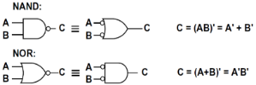**- NAND and NOR Gates**

**-Static 1/0-hazard:**本应该是保持1/0但有时候变成0/1

A static 1-hazard occurs in a SOP implementation when two minterms differing by only one input variable are not covered by the same product term

**-Dynamic hazard:** 当输出应该从1到0或者反过来的时候，the output may change three or more times

**触发器只有在使能信号上升和下降的时候内容才会变化，但是锁存器的变化是immediately**

**-Clocked D flip-flop(rising): Q+=D**

**-Clocked J-K flip-flop(falling): Q+=JQ’+K’Q**

**-Clocked T flip-flop(rising): Q+=QT’+Q’T=QxorT**

**-S-R (set-reset) latch: Q+=S+R’Q**

**-Gated D latch: Q+=GD+G'Q+DQ**

**-Mealy Circuit:** 输出与当前状态和当前输入有关

**-Moore Circuit:** 输出只与当前状态有关，但可以有输入

**-最优状态分配：**1.States which have the same next state (NS) for a given input should be given adjacent assignments 2. States that are the next states of the same state should be given adjacent assignments 3. States that have the same output for a given input should be given adjacent assignments **to clump 1’s together on K-map**

**-状态等价:** 两个状态等价的充要条件是对于每个输入X输出都一样并且下一个状态都一样。

**-Tristate logics:**

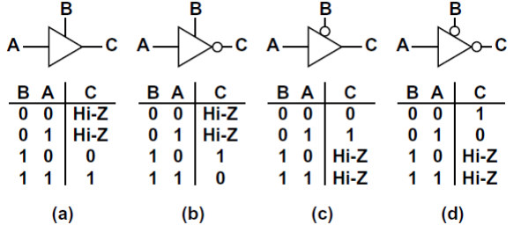

**CH2**

**-VHDL intro:**The actual circuit will depend on the compiler/optimizer being used; Top-down design;

1.Behavioral level：行为级，无需给出逻辑表达式；Data flow level：数据流级，需给出逻辑方程；Structural level：结构级，指定构成加电路的门和门之间的互连；

**-Concurrent statements:** 并列，语句右边的值变化就会马上执行; 如果没有指定delay, **delay=delta**

**the time statement executes≠the time signal updated**

**-标识符命名规则：**字母开头，可由字母、数字、下划线组成，不能下划线结尾，不能使用保留字；

**-初始值：**只对仿真有意义 :=

**-Buffer mode:** 表明是对外部世界的输出同时也能被结构里面读，inout表示是双向但是不是电路的外部输入

**-Process:** 当sensitive list里的信号发生变化之后进程开始执行，结束之后返回开头等待敏感列表里面信号变化

Processes, functions, and procedures are the onlysections of code that are executed sequentially但是这些代码块和外部的语句依然是并发的；**if语句不能用作进程外的并发语句；**函数中禁止进行信号声明和元件实例化

**-wait: 对于进程的敏感列表的替代方式是使用wait语句**

**wait on** sensitivity-list; 等待列表中信号发生变化

**wait for** time-expression; 等待一段时间经过

**wait for 0 ns = wait for a delta time**

**wait until** Boolean-expression; 当表达式中的信号变化时对表达式估值，为真就继续运行

**如果多个语句对一个信号赋值，最后的赋值会override**

**一个进程必须且只能包含敏感列表或者wait语句之一**

**-delay：分为传输延时和惯性延时**

**-Transport delay:** 单纯延时

signa <= **transport** expression **after** delay-time；

**-Inertial delays(d):** 不会将过短的脉冲从输入给输出, 如果脉冲宽度小于pulse-width就消除signal_name <= **reject** pulse-width **inertial** expression **after** delay-time;

实际上使用reject相当于用二者的组合：Z3 <= **reject** 4 ns **inertial** X **after** 10 ns; 等价于Zm <= X **after** 4 ns; Z3 <= **transport** Zm **after** 6 ns;

**-Simulation：**1.Analysis (compilation)分析（编译） 2. Elaboration细化 3. Simulation仿真

**-Elaboration：**① Ports are created for each instance of a component ②Memory storage is allocated for the required signals ③The interconnections among the port signals are specified ④A mechanism is established for executing VHDL statementsin the proper sequence；⑤The resulting data structure represents the digital system being simulated；

**如果一个model里面有多个进程，他们是并行的，这些进程和其他的语句也是并行的。**A process **takes no time** to execute unless it has wait statements in it. Signals **take** **delta time** to update when no delay is specified；

**-Data types:** Real and time types are not synthesizable

VHDL是强类型，如果类型不匹配那么需要显式的类型转换或者重载运算符

example：Ci为bit类型，A, B, Sum为unsigned，则应Sum<='0' & A+B+unsigned'(0=>Ci), bit不能直接与unsigned相加。

**-Operators: 从下到上优先级降低**

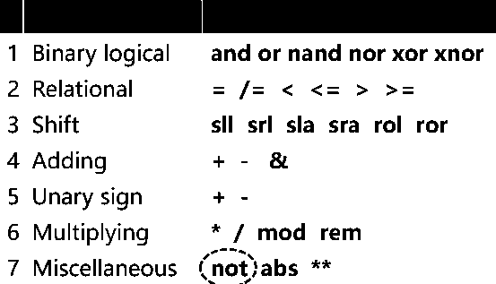

**-shift: l = logical, a = arithmetic**

**sll:** 左移补零 **srl**:右移补零 **rol:** 循环左移 **ror:** 循环右移

**sla:** 左移用最右边的位补 **sra:** 右移用最左边的位补

example：A = “10010101”，A sll 2="01010100"，A sla 3 ="10101111"，A ror 5 ="10101100"

**-条件信号赋值(simple when):**

signal_name <= expression1 **when** condition1

{**else** expression2 **when** condition2}

[**else** expressionN];

**-选择信号赋值(selected when):条件完全others可省略**

**with** expression_s **select**

signal_s <= expression1 [**after** delay-time] **when** choice1,

expression2 [**after** delay-time] **when** choice2,

...[expression_n [**after** delay-time] **when** **others**];

**-case（这个在process里用，上面两个都是并发的）**

**case** expression **is**

**when** choice1 => sequential statement1

**when** choice2 => sequential statement2

...[**when** **others** => sequential statements] **end** **case**;

**-IEEE:** Institute of Electrical and Electronic Engineers.

**- IEEE.std_logic:** has nine values, including '0', '1',

'X'(unknown), and 'Z' (high impedance) 没有运算

**- IEEE.numeric_bit:**有符号数用补码表示，有运算重载

“1011” + “110” = “1011” + “0110” = “0001”进位扔掉

**-Variables:** 信号在延迟后更新（new value generally

only available at the conclusion of the Process, Function, or Procedure），变量立即更新；信号用<=赋值，变量用:=赋值；信号必须在进程外声明和初始化，变量必须在进程内；变量的更新是立即的，后续计算会用新值。

**-数组:** 声明类型

**type** SHORT_WORD **is** **array** (3 downto 0) **of** bit;

实例**signal** word1: short_word :=”1101”;

**-多维数组:** 声明类型：**type** matrix **is** **array** (1 to 4, 3 downto 1) **of** integer；

实例**variable** mat : matrix := ( (1,2,3), (4,5,6), (7,8,9), (10,1,12) );

矩阵索引：mat(2, 1)，第2行最后一个；

**-无约束数组：**声明无约束数组：**type** int_vec **is** **array** (natural **range**<>) **of** integer；实例必须指明range：signal int_vec5 : int_vec(1 to 5) := (3, 2, 6, 8, 1)；声明字符串：**type** string **is** **array** ( positive **range** <> ) **of** character; 实例：**constant** string1 : string(1 to 29) :=“This string is 29 characters.”

**-Subtype:** 在声明类型之后，可以声明相关的子类型以包含该类型指定的值的子集。**subtype** short_word **is** bit_vector(15 downto 0)；

**-Loop:** [loop-label:] **loop** sequential statements **end** **loop** [loop-label]; exit：**exit**;或者**exit** **when** condition; loop是sequential的，只能在**进程函数过程**里面用，对于for-loop：[loop-label:] **for** loop-index **in** range **loop** sequential statements **end** **loop** [loop-label];**loop-index是进入循环之后自动定义的，不能被更改，但可以使用，loop结束后不可用** [loop-label:] **while** condition **loop** sequential statements **end** **loop** [loop-label];

**IF, WAIT, CASE, LOOP are intended exclusively for**

**sequential code，They can only be used inside a PROCESS（进程）, FUNCTION（函数） or PROCEDURE（过程）**

**CH3**

**-FPGA intro:** FPGA is IC(集成电路) that contain an array of identical logic blocks with programmable interconnections. The user can program the functions realized by each logic block and the connections between the blocks. FPGAS are **less dense** than traditional gate arrays. In FPGAS, **a lot of resources** are spent merely to achieve the needed programmability. Programmable points have resistance and capacitance. They **slow down** signals, so FPGAS are **slower** than traditional gate arrays. **Interconnection delays are unpredictable** in FPGAS. “Field” programmability is achieved by reconfigurable elements(可被用户控制). FPGA内部通常包含三个元素：**Programmable logic blocks、Programmable input/output blocks、Programmable routing resources.**

**-MPGA:** mask programmable gate arrays.

**-Layout of FPGA:** Arrays of programmable logic blocks are distributed within FPGA. Logic blocks are surrounded by input/output interface blocks. These I/O blocks can be considered to be on the periphery of the chip. They connect the logic signals to FPGA pins. The space between the logic blocks is used to route connections between the logic blocks.

**-Programmable logic blocks:** created by using multiplexers, look-up tables, and AND-OR or NAND-NAND arrays. Programming means：①changing the input or control signals to the multiplexers. ②changing the look-up table contents. ③selecting or not selecting particular gates in AND-OR gate blocks.

**-Programmable interconnect:** be required to interconnect various blocks in the chip and to connect specific I/O pins to specific logic blocks. Programming means making or breaking specific connections.

**-Programmable l/O blocks:** can be programmed to be input, output, or bidirectional lines(双向线路).

The general-purpose interconnect gives FPGA a lot of **flexibility** But it has the disadvantage of being **slow**

**-Architectures for FPGAs:** Matrix-based(symmetrical array) architecture：矩阵(对称阵列)型、Row-based architecture：横向型、Hierarchical PIL architecture：从属型、Sea-of-gate architecture：门海型；classification is based on the layout of the general purpose logic region in the FPGA

**-Matrix-based Architecture:** The logic blocks are organized in a matrix-like fashion. The logic blocks in these architectures are typically of a large granularity(粒度) ( capable of Implementing 4-variable functions or more). These architectures typically contain 8×8 arrays in the smaller chips and 100×100 or larger arrays in the bigger chips. 二维通道布线Two-dimensional channeled routing：routing resources are generally available in horizontal and vertical directions.

**-Row-based architecture：**The logic blocks in this architecture are organized into rows. There are rows of logic blocks and routing resources. 一维通道布线One-dimensional channeled routing：the routing resources are located as a channel in between rows of logic resources.

**-Hierarchical architecture:** Blocks of logic cells are grouped together by a local interconnect. Several such groups are interconnected by another level of interconnect. There is a hierarchy in the organization of these FPGAs：①these FPGAs contain clusters of logic blocks with localized resources for interconnection. The global interconnect network is used for the interconnections between the clusters of logic blocks.

**-Sea-of-gate architecture:** The general FPGA fabric(结构) consists of a large number of gates. There is an interconnect **superimposed on the sea of gates.**

**-reconfigurability:** can be achieved by：①changing the contents of static RAM cells；②changing the contents of flash memory cells；③fusing metal links. FPGAS use one of the following programming methods：①StaticRAM programming technology；(key idea is to use **pass transistors** to create switches and then control them using SRAM content)

②EPROM/ EEPROM/ flash programming technology；

③AntiFuse programming technology **(irreversible, but faster)**

**Only SRAM and EEPROM/Flash programming technologies allow in-circuit programmability在线可重构编程**

**-Routing Matrix for General-Purpose Interconnection in an FPGA:** Many FPGAS use switch matrices that provide interconnections between routing wires connected to the switch matrix. Each cross point in the switch matrix must support **six** possible interconnections.

**-Direct Interconnects between Neighboring Logic Blocks:** Many FPGAS provide direct interconnections to the four nearest neighbors(有时是8邻域)。直接互连不通过开关矩阵，而是通过专用dedicated switches开，延迟小。

**-Global Lines:** For purposes such as high fan-out and low-skew clock distribution, most FPGAs provide routing lines that span the entire width/height of device. A limited number ( two or four ) of such global lines are provided by many FPGAS in the horizontal and vertical directions.

**-Typical Routing Resources in a Row-Based FPGA:**

The interconnects in row-based channeled architecture can be classified into two categories：non-segmented routing、segmented routing

**-I/O Block:** I/O blocks on modern FPGAs allow use of the pin as input and/or output, in direct (combinational) or latched forms, in tristate true or inverted forms, and with a variety of I/O standards. To use the cell as an **output**. The tristate buffer must be enabled. To use the cell as an **input**, the tristate control must be set to place the tristate buffer, which drives the output pin, in the high-impedance state.

**CH4**

**-Design:** Design methodology splits a design into a "data path" and a "controller". ①**Controller**：sends control signals or commands to data path and obtain feedback(status signals) from data path. ②**Data path**: hardware that actually performs the data processing.

**-CLA:** 先行进位加法器 Carry look-ahead adders. Ci+1 = Ai·Bi + (Ai ⊕ Bi)·Ci = Gi + Pi，Gi = Ai·Bi，Pi = Ai ⊕ Bi. **Gi**= indicates whether a stage should generate a carry. **Pi**= indicates whether an adder should propagate the carry it receives from the lower stage. 优点：delays will be the same independent of the number of bits we need to add. 缺点：4bit以上逻辑复杂 CLA adders are usually implemented as 4-bit modules and are used in a hierachical structure to realize 4n-bit adders.

**-State Graphs for Control Circuits:** If an arc is labeled with XiXj /ZpZq , it means ①if inputs Xi and Xj are 1 (we don't care what the other inputs are), ②outputs Zp and Zq are 1 (and the other outputs are 0) ③and we traverse this arc to the next state. In general, if we label an arc with an input expression, I, we will traverse the arc when **I=1. Constraints on the input labels:** ①If Ii and Ij are any pair of input labels on arcs exiting state Sk , then Ii·Ij = 0 ②if i≠j If n arcs exit state Sk and the n arcs have input labels I1 , I2 , ... ,In , respectively, then I1+I2+...+In = 1

**-Score Board:** 2位BCD计数inc/dec信号，数码管显示，复位信号超过5个cycle清零

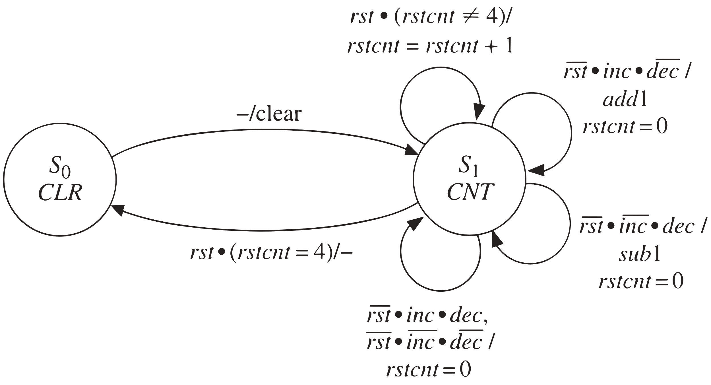

**-Synchronization and Debouncing:** 去抖动:remove the transients in the switch output. **Three flip-flops can provide debouncing, synchronization, and single pulsing.**

**-Add-and-Shift Multiplier:** Multiplicand=被乘数A, Multiplier=乘数B, A*B=C; 串并乘法器: Multiplier bits are processed serially, but the addition takes place in parallel.

**-Array Multiplier:** Array of AND gates and adders to perform

multiplication. This multiplier has no sequential logic or registers. 全加器3输入, 半加器2输入. Carry must propagate along each row of cells. Sum must propagate from row to row. **n-bit-by-n-bit array multiplier requires：n^2与门, n(n-1)加法器. Array multiplier:** number of components required increases **quadratically**; **Serial-parallel multiplier:** the amount of hardware required in addition to the control circuit increases **linearly with n. worst-case multiply time: (3n-4)tad+tg，tag=加法器延时, tg=与门延时**

**- Signed number representations:** 有符号的4-bit二进制数: +8没有原反补码; -8没有原码反码, 补码为1000; +0原反补码皆为0000; -0原码1000, 反码1111, 补码0000; **反码One’s complement：正数反码等于原码，负数的反码等于相反数的按位取反; 补码Two’s complement：正数补码等于原码，负数补码等于求出反码之后+1(+0例外)。**

**-Fraction:** The **leftmost bit** represents the sign of the fraction (sign bit). A signed binary fraction x0 .x-1x-2x-3 represents the quantity x0 (-2^0 ) + x-1 (2^-1 ) + x-2 (2^-2 ) + x-3 (2^-3 ) Example:

(0.101)two=0*(-2^0)+1*(2^-1)+0*(2^-2)+1*(2^-3)=5/8；

(1.011)two=1*(-2^0)+0*(2^-1)+1*(2^-2)+1*(2^-3)=-5/8

从右边开始找到第一个1，对他左边的取反，比如：(0.101)two=( 5/8)dec，(1.011)two=(-5/8)dec

**0.111...** is the largest positive fraction,无法用补码表达1.

**特例: (1.000)two=(-1)dec (0.111)two=(7/8)dec**

**-A Signed Integer/Fraction Multiplier**

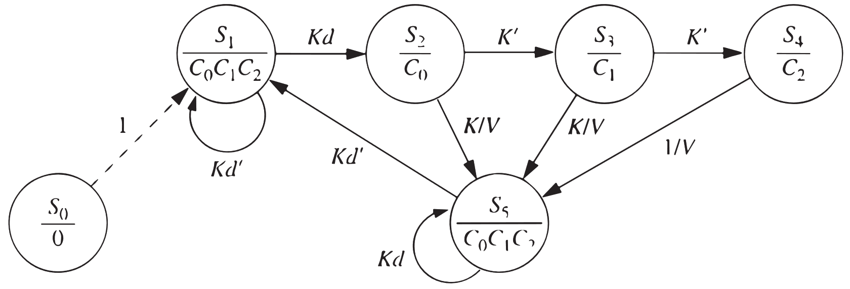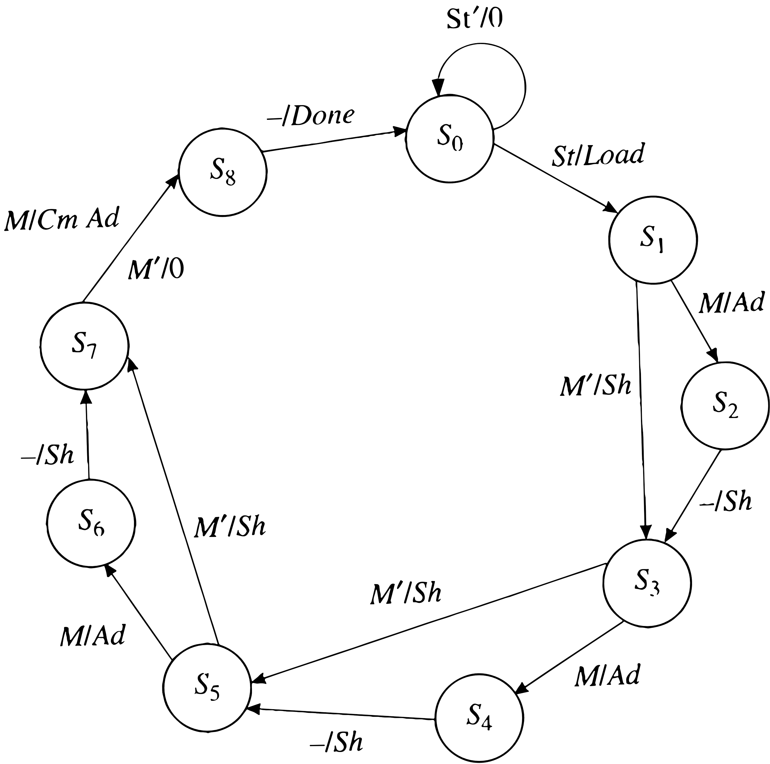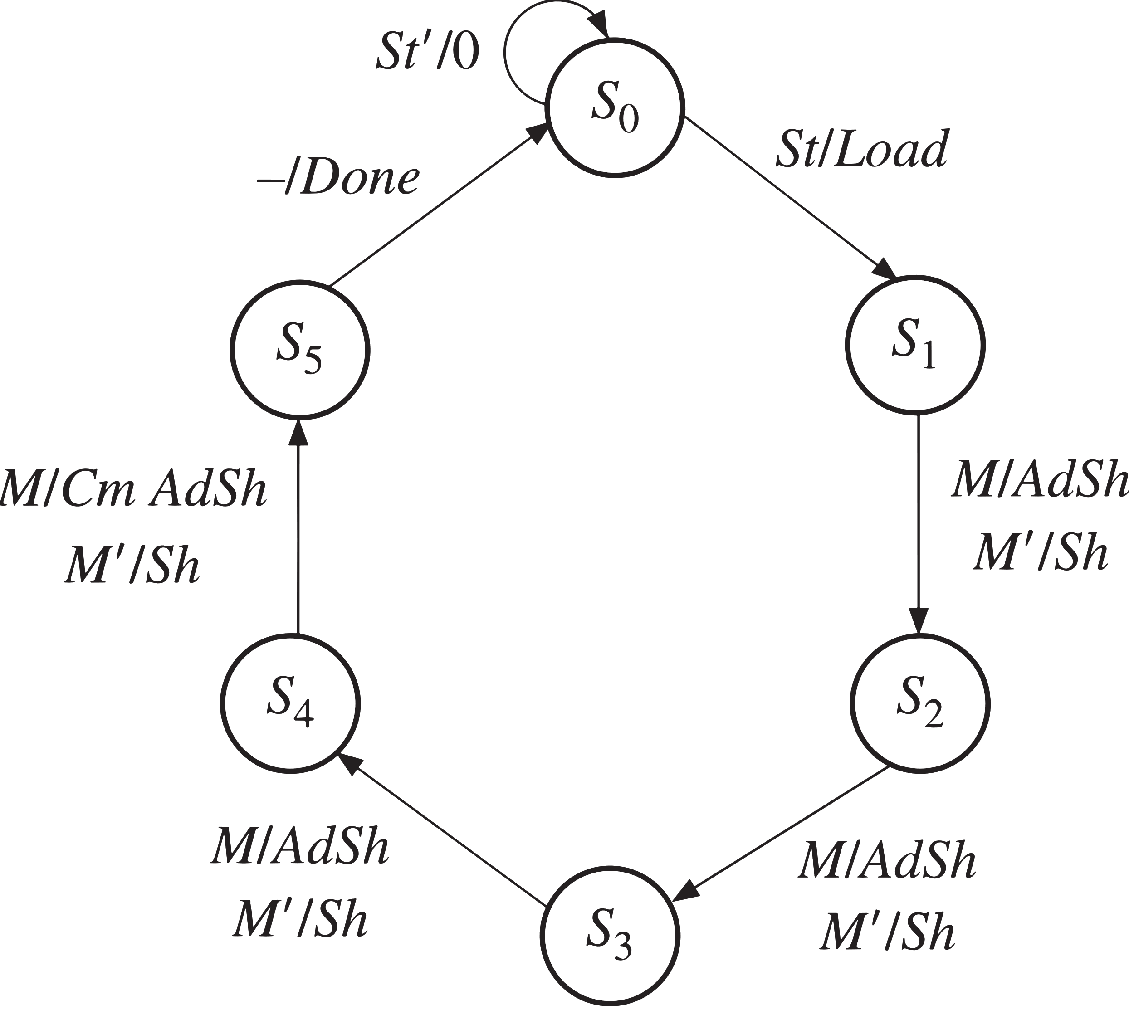

**-Keypad Scanner**

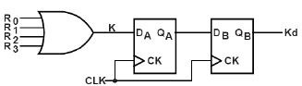

**-Binary Dividers**

**Unsigned**:

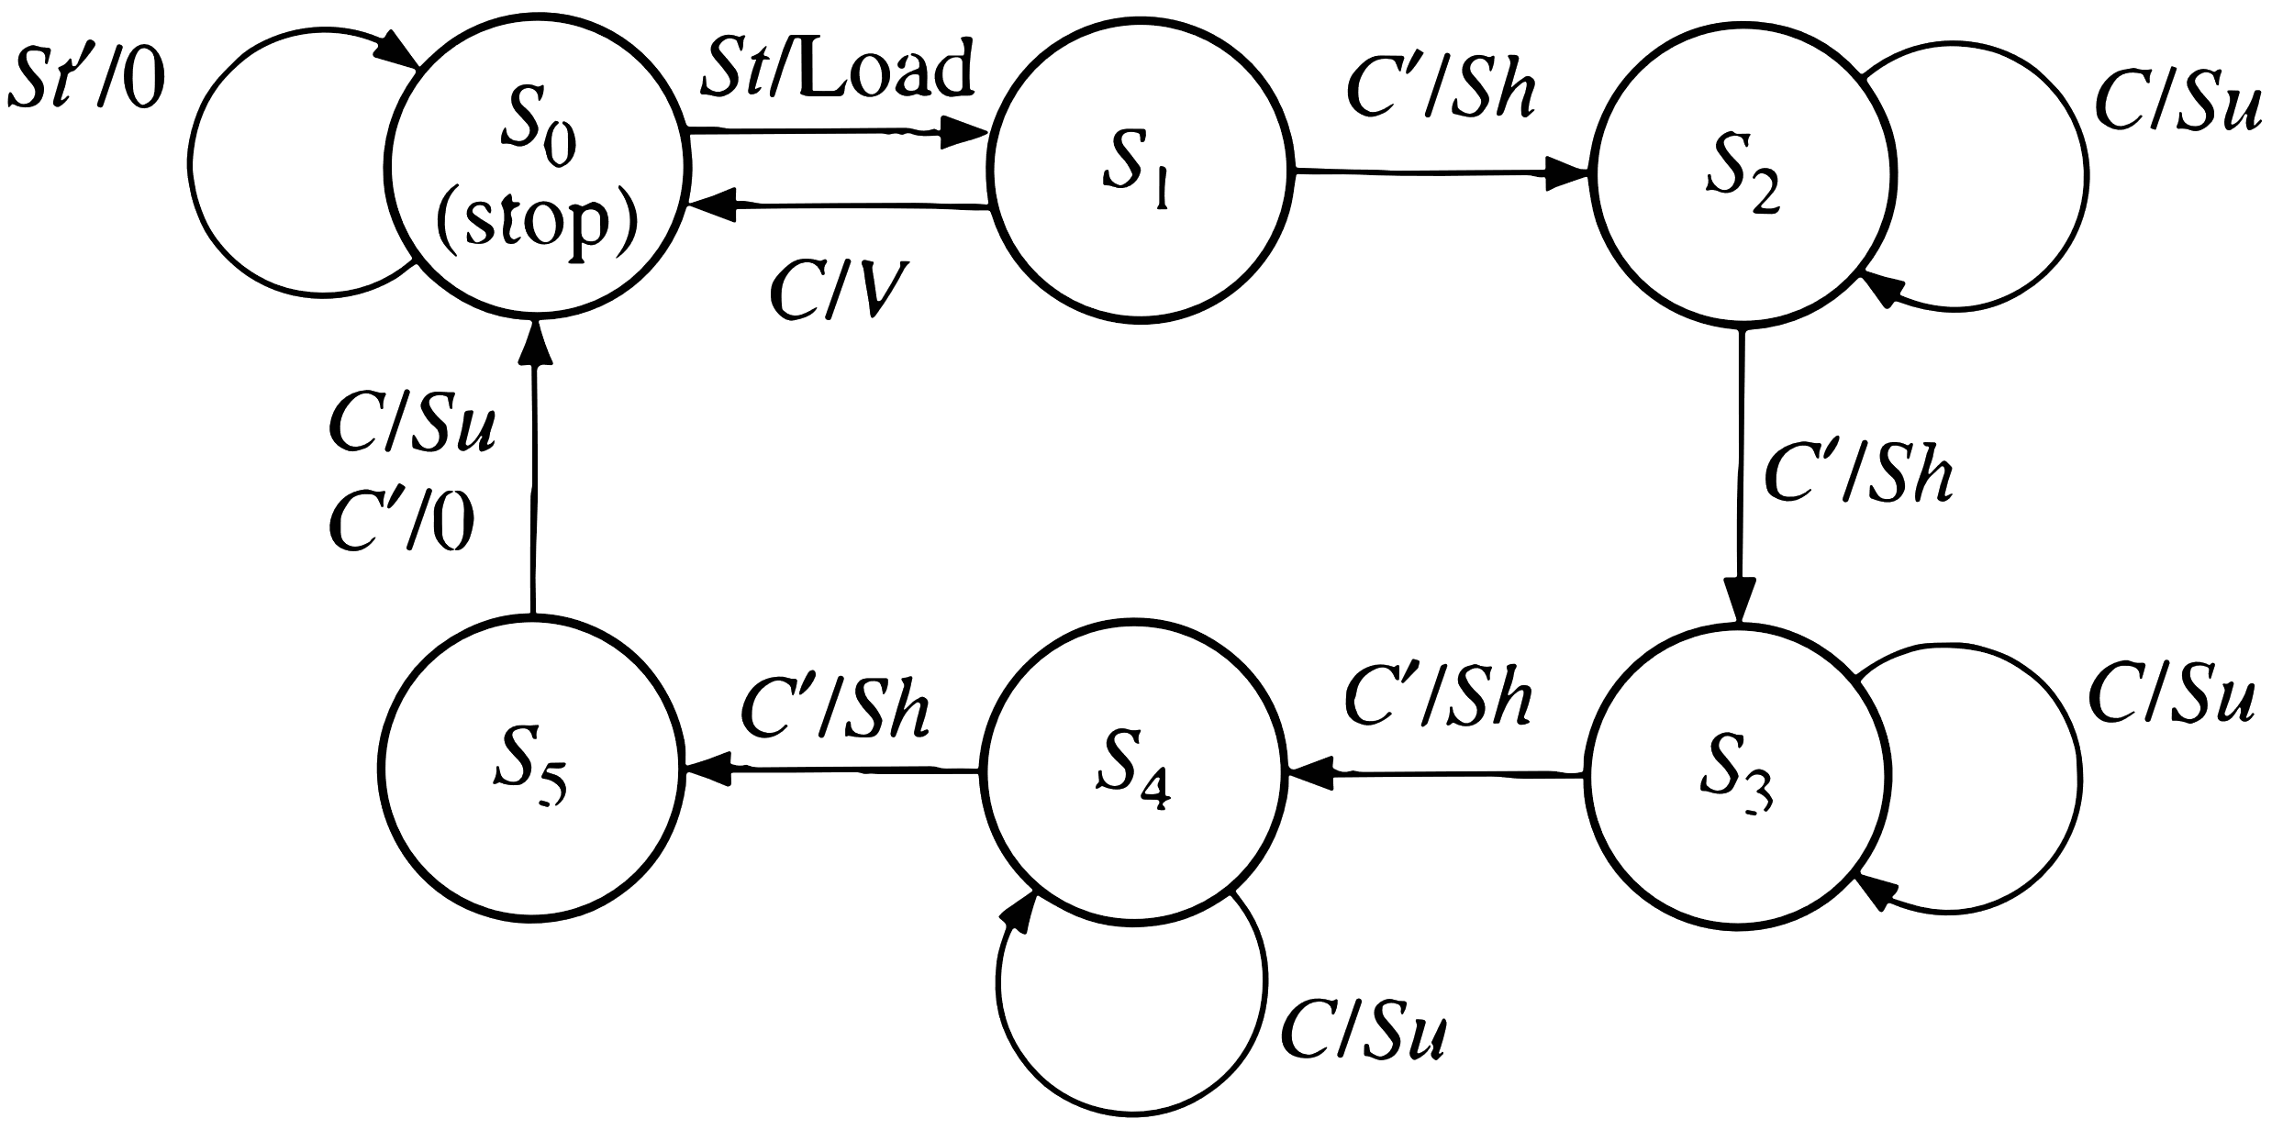

**Signed**:

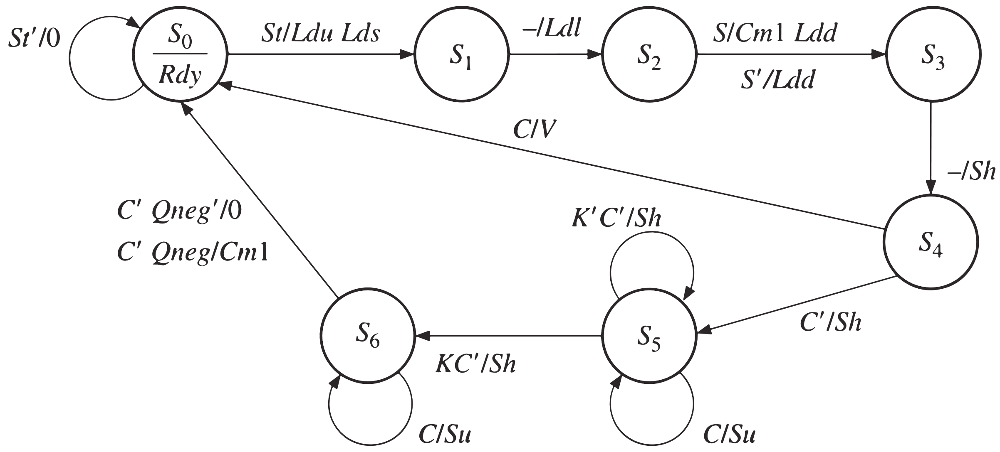

**CH5**

­**-SM Charts intro:** SM is used to control a digital system carries out a **step-by-step** procedure or algorithm; **State graphs, state tables, and ASM charts** are different forms of FSM (Finite State Machine) representations

**-State Graph:** Proper state graph must obey some conditions: ①One and exactly one transition from a state must be true at any time；②Next state must be uniquely defined for every input combination.**(Automatically satisfied for an SM chart）**

**-SM Chart: state box, decision box, conditional output box.** **SM chart is constructed from SM blocks：one state box、one entrance path、N exit path.** No internal feedback within an SM block is allowed. SM block can have several parallel paths that lead to the same exit path. More than one of these paths can be active at the same time. All the tests take place within **one clock time** in both parallel and serial forms.

**-Converting a State Graph to an SM Chart:** Moore outputs: **in state boxes**. Mealy outputs: **in conditional output boxes**.

Moore outputs change immediately **following a state change**, Mealy outputs change immediately **after a state change or an input change**. **All outputs will have their correct values at the time of the active edge.**

**-Realization of SM Charts** Example:

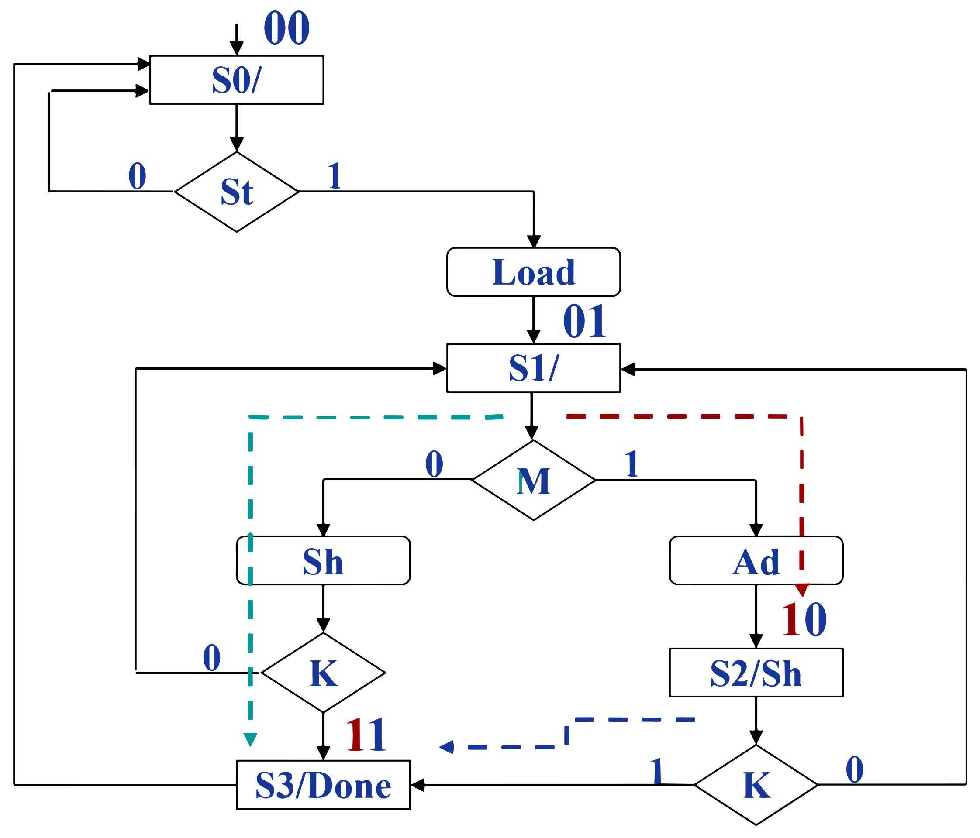

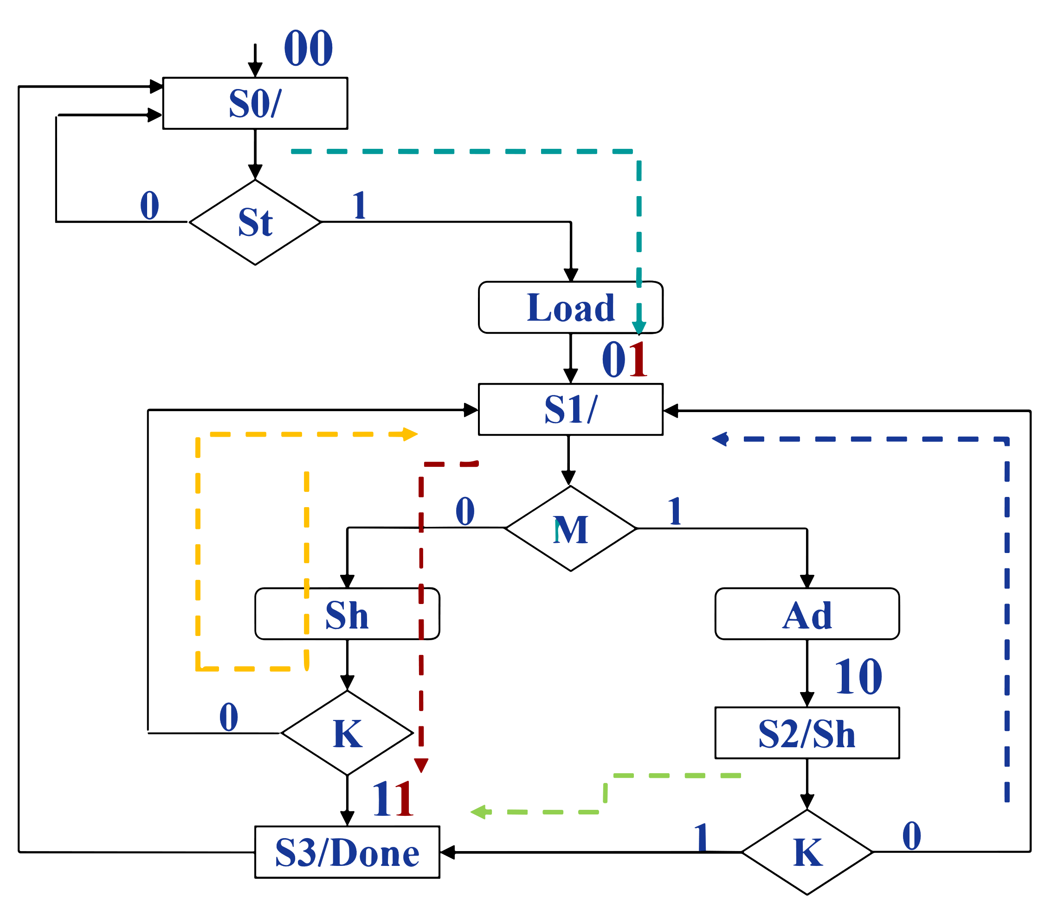

A+= A'BM'K + A'BM + AB'K =A'B(M+K)+AB'K

B+= A'B'St+A'BM'(K+K')+AB'(K+K')=A'B'St+A'BM'+AB'

每个case写一个block的代码

**CH6**

Functions返回single value, use **return** statement

Procedures 返回any number of values, use **output** statement

**-Functions:** Functions, procedures: subprograms(子程序)

**wait语句、信号声明、component实例化不能用在函数里**

A function is a section of **sequential** code. The same statements that can be used in a process (**if, case, loop**) can also be used in a function, with the exception of **wait.**

Actual parameters are treated as input values and **cannot be changed** during the execution of the function不能给输入赋值，可以函数内定义中间变量初始化为输入值然后去处理

**For function, out or inout are not allowed**

**-Procedures:** Procedure call can be a **sequential or concurrent** statement. Within procedure declaration: class (constant/signal/variable), mode, type are specified. **对mode=in则默认的class=constant; 对mode=out和inout则默认的class=variable; Parameters of modes out and inout can be changed in the procedure;**

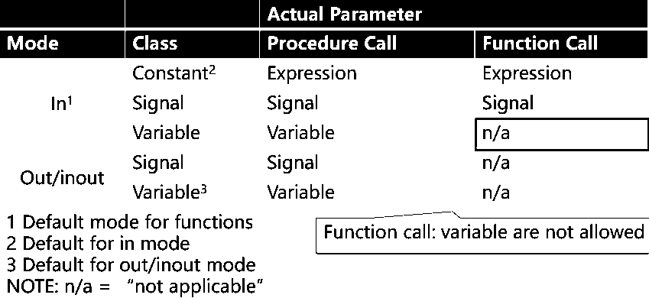

**-Process, Function, Procedure:**①The only pieces of sequential code②Employ same sequential statements (if, case, loop; **wait not allowed in function**)③进程: intended for immediate use in main code④函数和过程: mainly for library

**-Package:** package and package body must have the same name; 只有当包含一个或者多个subprogram的时候Package body才是必需的;

**package** package_name **is**

(declarations)

**end** package_name;

[**package** **body** package_name **is**

(function and procedure descriptions)

**end** package_name;]

**-Component:** component declaration中的port和entity declaration里面port形式一样; component的实例必须有label;

**-Attributes:** Attributes can be associated with signals and arrays. VHDL有两种attributes: attributes that return a **value**、attributes that return a **signal; Event事件=a change in the signal**; **Transaction事务=the signal is evaluated, regardless of whether the signal changes or not**

**-Attributes That Return a Value**

①s'event：如果在Δ时间内发生时间就返回True；

②s'active：如果Δ时间内发生transaction，返回True；③s'last event：返回距离上一个事件的时间；

④s'last value：上一个值；

⑤s'last active：返回距离上一个transaction的时间；b.返回信号：

**-Attributes That Create a Signal [(Time)]可选默认1个Δ**

①s'delayed[(time)]：返回延时了time的信号s，time可选；

②s'stable[(time)]：返回Boolean signal，如果指定时间(preceding)内s没有发生events，信号值为true；

③s'quiet[(time)]：返回Boolean signal，如果指定时间(preceding)内s没有发生transaction，信号值为true(初始值为false)；

④s'transaction：bit signal，s发生transaction时，该信号发生翻转(初始值1)；

**-Array Attributes:**

A can either be an array name or an array type

**-4-Valued Logic System:**

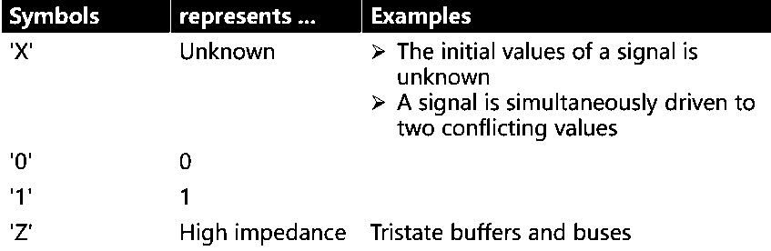

**-Signal Resolution Functions:** necessary when different wires in a system are driving a common signal path; VHDL with multivalued logic can be used to create resolutions when signals are connected. **Resolved signals have an associated resolution function;** With unresolved signals, if we drive a bit signal to two different values in two concurrent statements, the compiler will flag an error;

**-IEEE 9-Valued Logic System:**

①‘U’：未初始化； ②‘0’：强0； ③‘1’：强1；

④‘X’：强未知； ⑤‘Z’：高阻态； ⑥‘W’：弱未知；

⑦‘L’：弱0； ⑧‘H’：弱1； ⑨‘-’：无所谓；

大多数只限于仿真，‘0’, ‘1’ and ‘Z’ 可综合，无限制。

区别：①‘1’：as perfect as the power supply voltage；②‘H’：logically high, but has a voltage drop；③‘0’：perfect ground；④‘L’：logically low；**If a forcing signal and a weak signal are tied together, the forcing signal dominates.**

|  |  |  |  |  |  |  |  |  |  |
| --- | --- | --- | --- | --- | --- | --- | --- | --- | --- |
|  | **U** | **X** | **0** | **1** | **Z** | **W** | **L** | **H** | **-** |
| **U** | U | U | U | U | U | U | U | U | U |
| **X** | U | X | X | X | X | X | X | X | X |
| **0** | U | X | 0 | X | 0 | 0 | 0 | 0 | X |
| **1** | U | X | X | 1 | 1 | 1 | 1 | 1 | X |
| **Z** | U | X | 0 | 1 | Z | W | L | H | X |
| **W** | U | X | 0 | 1 | W | W | W | W | X |
| **L** | U | X | 0 | 1 | L | W | L | W | X |
| **H** | U | X | 0 | 1 | H | W | W | H | X |
| **-** | U | X | X | X | X | X | X | X | X |

std_logic is a subtype of std_ulogic

IEEE.numeric_std package uses std_logic

**-SRAM Model**

**n** address lines, **m** data lines, **3** control lines: **CS_b, OE_b, WE_b**

This memory can store **2^n** words, each **m** bits wide

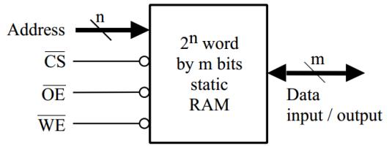

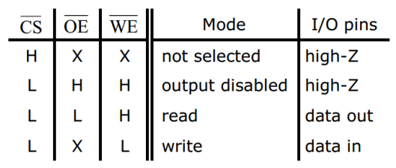

CS_b: chip select selects memory chip so that memory read and write operation are possible; OE_b: output enables memory output onto an external bus; WE_b: write enable data to be written to RAM; Writing to the latches in the memory cells is not completed until: ①**WE_b goes high** ②**CS_b goes high.**

**-Generics:** generics is a way of specifying a generic parameter; Generic parameter is a static parameter; It can be easily modified and adapted to different applications

**generic** (n : **integer** := 8); Whenever n is found in the entity itself or in the architecture that follows, its value will be assumed to be 8

**-Named association:** 按位置或者显式地指定

**-Generate Statements:**

for生成语句：编译的时候会按照规则生成一系列语句

generate_label: **for** identifier **in** range **generate**

[**begin**]

concurrent statement(s)

**end** **generate** [generate_label];

**-Conditional Generate：**条件为真的时候生成，不允许else

generate_label: **if** condition **generate**

[**begin**]

concurrent statement(s)

**end** **generate** [generate_label];

**———————————————————————————**

**-Sequence Detector：检测101**

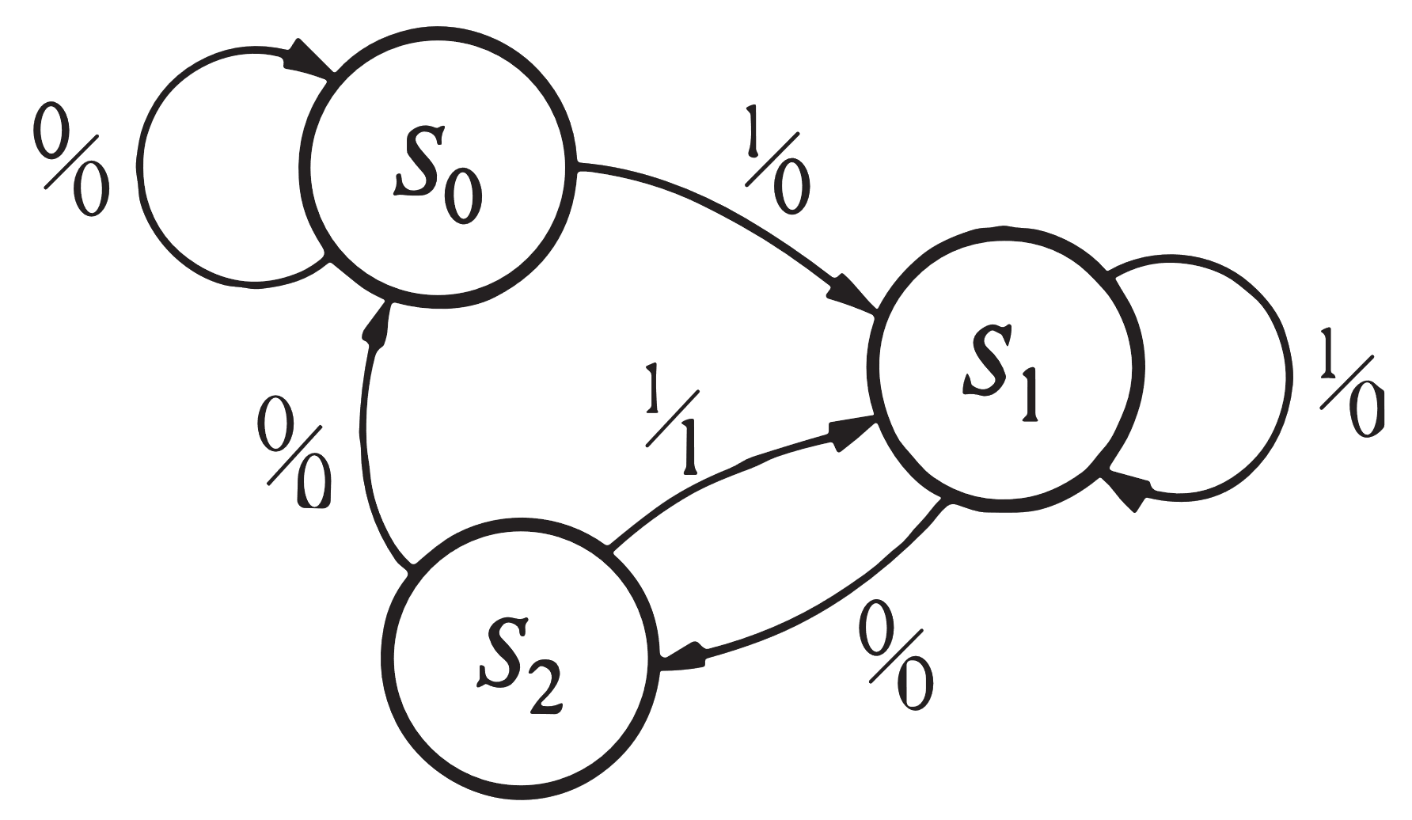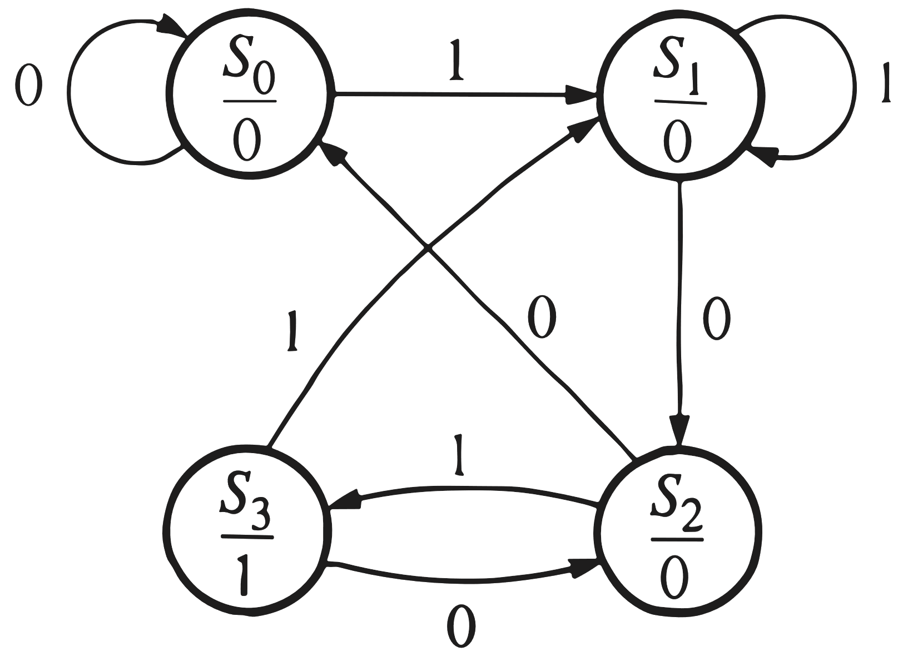

**-NRZ to Mancherst**

Manchester code: 0=前半0后半1，1=前半1后半0

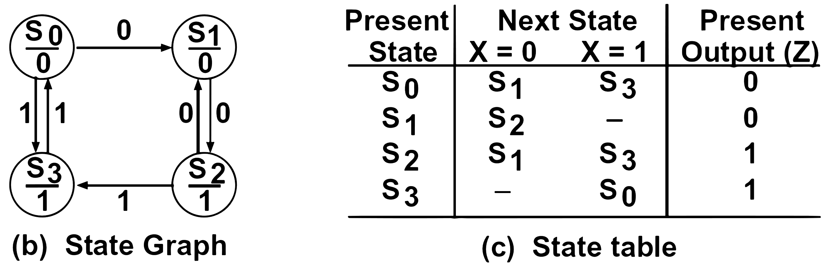

**-BCD to Seven-Segment Display Decoder**

**entity** bcd_seven **is**

**port**(bcd: **in** bit_**vector**(3 **downto** 0); seven: **out** bit_**vector**(7 **downto** 1));

**end** bcd_seven;

**architecture** behavioral **of** bcd_seven **is**

**begin**

**process**(bcd)

**begin**

**case** bcd is

**when** "0000" => seven <= "0111111";

**when** "0001" => seven <= "0000110";

**when** "0010" => seven <= "1011011";

**when** "0011" => seven <= "1001111";

**when** "0100" => seven <= "1100110";

**when** "0101" => seven <= "1101101";

**when** "0110" => seven <= "1111101";

**when** "0111" => seven <= "0000111";

**when** "1000" => seven <= "1111111";

**when** "1001" => seven <= "1101111";

**when** **others** => **null**;

**end** **case**;

**end** process;

**end** behavioral;

**-A BCD Adder**

**library** **IEEE**;

**use** IEEE.numeric_bit.all;

**entity** BCD_Adder is

**port**(X, Y: **in** **unsigned**(7 **downto** 0); Z : **out** **unsigned**(11 **downto** 0));

**end** BCD_Adder;

**architecture** BCDadd **of** BCD_Adder **is**

**alias** Xdig1: **unsigned**(3 **downto** 0) **is** X(7 **downto** 4);

**alias** Xdig0: **unsigned**(3 **downto** 0) **is** X(3 **downto** 0);

**alias** Ydig1: **unsigned**(3 **downto** 0) **is** Y(7 **downto** 4);

**alias** Ydig0: **unsigned**(3 **downto** 0) **is** Y(3 **downto** 0);

**alias** Zdig2: **unsigned**(3 **downto** 0) **is** Z(11 **downto** 8);

**alias** Zdig1: **unsigned**(3 **downto** 0) **is** Z(7 **downto** 4);

**alias** Zdig0: **unsigned**(3 **downto** 0) **is** Z(3 **downto** 0);

**signal** S0, S1: **unsigned**(4 **downto** 0);

**signal** C: **bit**;

**begin**

S0 <= '0'&Xdig0 + Ydig0;

Zdig0 <= S0(3 **downto** 0) + 6 **when** S0 > 9

**else** S0(3 **downto** 0); -- add 6 if needed

C <= '1' **when** S0 > 9 **else** '0';

S1 <= '0' & Xdig1 + Ydig1 + **unsigned'(0=>C)**;

Zdig1 <= S1(3 **downto** 0) + 6 **when** S1 > 9

**else** S1(3 **downto** 0);

Zdig2 <= "0001" **when** S1 > 9 **else** "0000";

**end** BCDadd;

**-Keyboard Scanner**

**S1**: wait with output C0=C1=C2=1 until a key is pressed

**S2**: C0=1, so if the pressed key is in column 0, K = 1, and the circuit outpus V=1 and goes to S5

**S3**, **S4**: If no key is found in column 0, column 1 is checked, and if necessary, column 2 is checked

**S5**: The circuit waits until all key are released and Kd goes to 0 before resetting

**entity** scanner **is**

**port**(R0, R1, R2, R3, CLK: **in** **bit**; C0, C1, C2: **inout** **bit**;

N0, N1, N2, N3, V: **out** **bit**);

**end** scanner;

**architecture** behavior **of** scanner **is**

**signal** QA, K ,Kd: **bit**;

**signal** state, nextstate: **integer** **range** 0 to 5;

**begin**

K <= R0 **or** R1 **or** R2 **or** R3;

N3 <= (R2 **and** **not** C0) **or** (R3 **and** **not** C1);

N2 <= R1 **or** (R2 **and** C0);

N1 <= (R0 **and** **not** C0) **or** (**not** R2 **and** C2) **or** (**not** R1 **and** **not** R0 **and** C0);

N0 <= (R1 **and** C1) **or** (**not** R1 **and** C2) **or** (**not** R3 **and** **not** R1 **and** **not** C1);

**process**(state, R0, R1, R2, R3, C0, C1, C2, K, Kd, QA)

**begin**

C0 <= '0'; C1 <= '0'; C2 <= '0'; V <= '0';

**case** state **is**

**when** 0 => nextstate <= 1;

**when** 1 => C0 <= '1'; C1 <= '1'; C2 <= '1';

**if** (Kd **and** K) = '1' **then** nextstate <= 2;

**else** nextstate <= 1;

**end** **if**;

**when** 2 => C0 <= '1';

**if** (Kd **and** K) = '1' **then** V <= '1'; nextstate <= 5;

**elsif** K = '0' **then** nextstate <= 3;

**else** nextstate <= 2;

**end** **if**;

**when** 3 => C1 <= '1';

**if** (Kd **and** K) = '1' **then** V <= '1'; nextstate <= 5;

**elsif** K = '0' **then** nextstate <= 4;

**else** nextstate <= 3;

**end** **if**;

**when** 4 => C2 <= '1';

**if** (Kd **and** K) = '1' **then** V <= '1'; nextstate <= 5;

**else** nextstate <= 4;

**end** **if**;

**when** 5 => C0 <= '1'; C1 <= '1'; C2 <= '1';

**if** Kd = '0' **then** nextstate <= 1;

**else** nextstate <= 5;

**end** **if**;

**end** **case**;

**end** **process**;

**process**(CLK)

**begin**

**if** CLK = '1' **and** CLK'EVENT **then**

state <= nextstate;

QA <= K;

Kd <= QA;

**end** **if**;

**end** **process**;

**end** behavior;

**-UART**

When no data is being transmitted, D remains high.

**library** IEEE;use IEEE.std_logic_1164.**all**;

**use** IEEE.numeric_std.**all**;-use this if unsigned type is used.

**entity** UART_Transmitter **is** **port**(Bclk,sysclk,rst_b,TDRE,loadTDR:in std_logic;

DBUS:**in** unsigned(7 **downto** 0);

setTDRE,TxD:**out** std_logic);

**end** UART_Transmitter;

**architecture** xmit **of** UART_Transmitter **is**

**type** stateType **is** (IDLE,SYNCH,TDATA);

**signal** state,nextstate:stateType;

**signal** TSR:unsigned(8 **downto** 0);- Shift Register

**signal** TDR:unsigned(7 **downto** 0);-- Data Register

**signal** Bct:integer **range** 0 **to** 9;

**signal** inc,clr,loadTSR,shftTSR,start:std_logic;

**signal** Bclk_rising,Bclk_Dlayed:std_logic;

**begin**

TxD <=TSR(0);

setTDRE <= loadTSR;

Bclk_rising <= Bclk **and** (**not** Bclk_Dlayed); -indicates the rising edge of bit clock

Xmit_Control: **process**(state,TDRE,Bct,Bclk_rising)

**Begin**

inc <='0';clr <='0';loadTSR <='0';shftTSR <='0';start <='0'; -reset

**case** state **is**

**when** IDLE =>

**if** (TDRE =‘0')**then**

loadTSR <='1';nextstate <=SYNCH;

**else** nextstate <=IDLE;**end** **if**;

**when** SYNCH => --synchronize with the bit clock

**if** (Bclk_rising ='1')**then**

start <='1';nextstate <=TDATA;

**else** nextstate <=SYNCH;**end if;**

**when** TDATA =>

**if** (Bclk_rising '0')**then** nextstate <TDATA;

**elsif** (Bct /=9)**then**

shftTSR <='1';inc <='1';nextstate <=TDATA;

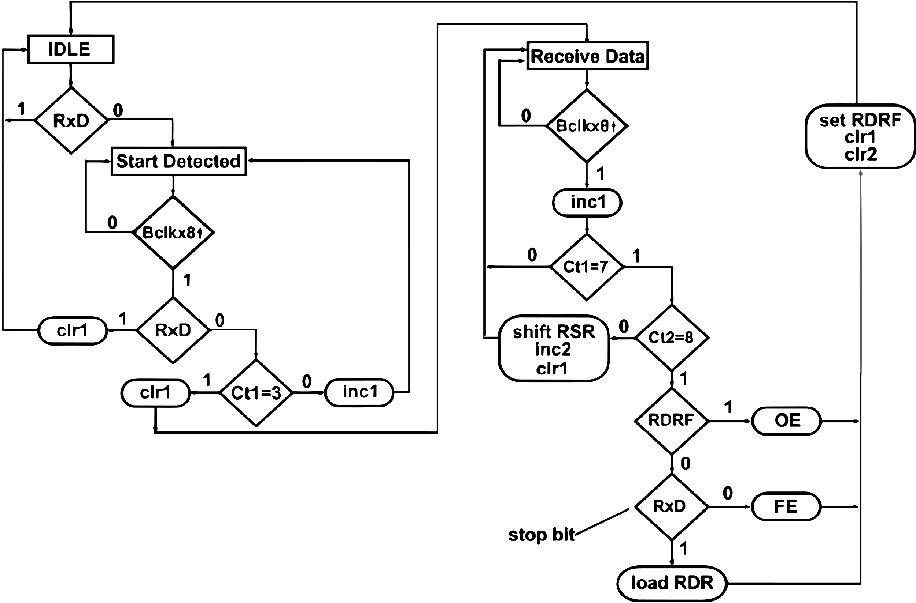**else** clr <='1';nextstate <=IDLE;**end if;**

**end case;end process;**

Xmit_update:**process**(sysclk,rst_b)

**Begin**

**if** (rst_b='0')**then**

TSR <="111111111";

state<=IDLE;Bct <=0;Bclk_Dlayed <='0';

**elsif** (sysclk'event **and** sysclk='1')**then**

state <=nextstate;

**if** (clr ='1')**then** Bct <=0;

**elsif** (inc='1')**then** Bct <=Bct+1;**end if;**

**if** (loadTDR ='1')**then** TDR <=DBUS;**end if;**

**if** (loadTSR='1')**then** TSR <=TDR&'1';**end if;**

**if** (start ='1')**then** TSR(0)<='0';**end if;**

**if** (shftTSR ='1')**then** TSR <'1'&TSR(8 downto 1);

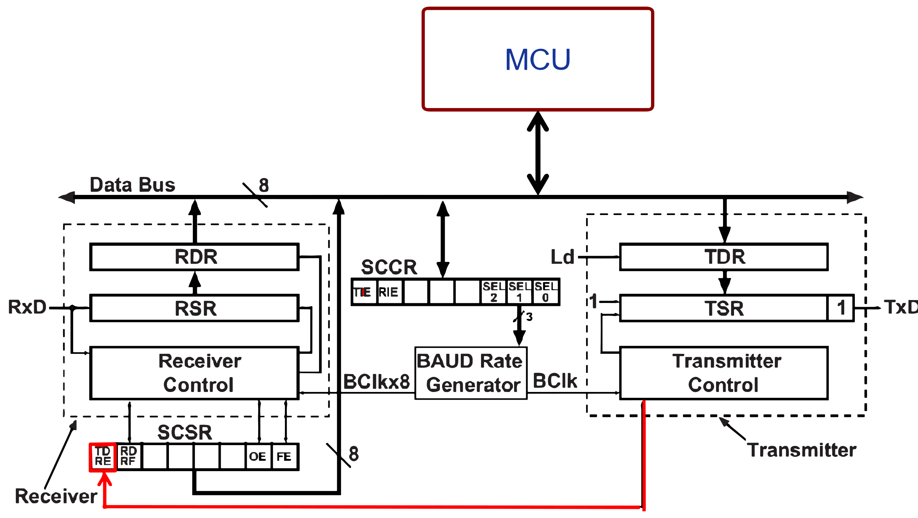**end if;** --shift out one bit

Bclk_Dlayed <=Bc1k;--Bclk delayed by 1 sysclk

**end if; end process; end xmit;**

**entity** UART_Receiver **is**

**port**(RxD,BclkX8,sysclk,rst_b,RDRF:**in** std_logic;

RDR:**out** unsigned(7 **downto** 0);

setRDRF,setOE,setFE:**out** std_logic);

**end** UART_Receiver;

**architecture** rcvr **of** UART_Receiver **is**

**type** stateType **is** (IDLE,START_DETECTED,RECV_DATA);

**signal** state,nextstate:stateType;

**signal** RSR:unsigned(7 **downto** 0);-receive shift register

**signal** ctl integer **range** 0 **to** 7;--indicates when to read the RxD input

**signal** ct2 integer **range** 0 **to** 8;--counts number of bits read

**signal** inc1,inc2,clr1,clr2,shftRSR,loadRDR:std_logic;

**signal** BclkX8_Dlayed,BclkX8_rising:std_logic;

begin

BclkX8_rising <=BclkX8 **and** (**not** BclkX8_Dlayed);-indicates the rising edge of bitX8 clock

Rcvr_Control: **process**(state,RxD,RDRF,ct1,ct2,BclkX8_rising)

**begin**

-reset control signals

inc1<='0';inc2<='0';c1r1<='0';c1r2<='0';

shftRSR <='0';loadRDR<='0';setRDRF<='0';setOE <='0';setFE <='0';

**case** state **is**

**when** IDLE =>

if (RxD ='0')**then** nextstate <=START_DETECTED;

**else** nextstate <=IDLE;**end if;**

**when** START_DETECTED =>

if (BclkX8_rising '0')

**then** nextstate <=START_DETECTED;

**elsif** (RxD='1')**then** clr1 <='1';nextstate <=IDLE;

**elsif**(ct1=3)**then**clr1 <='1';nextstate<=RECV_DATA;

**else** incl <='1';nextstate <=START_DETECTED;

**end if;**

**when** RECV_DATA =>

**if** (BclkX8_rising='0')**then** nextstate <=RECV_DATA;

**else** incl <='1';

**if** (ct1 /=7)**then** nextstate <=RECV_DATA;

--wait for 8 clock cycles

**elsif** (ct2 /=8)**then**

shftRSR <'1';inc2 <'1';clr1 <='1';

--read next data bit

nextstate <=RECV_DATA;

**else**

nextstate <IDLE;

setRDRF<='1';c1r1<='1';c1r2<='1';

**if** (RDRF '1')**then** setOE <='1';

**elsif** (RxD '0')**then** setFE <='1';

**else** loadRDR <='1';**end if;**

**end if;end if;end case;end process;**

Rcvr_update:**process**(sysclk,rst_b)

**begin**

if (rst_b='0')**then** state<=IDLE;BclkX8_Dlayed <=0';

ct1<=0;ct2<=0;

**elsif** (sysclk'event **and** sysclk='1')**then**

state<=nextstate;

**if** (clr1='1')**then** ct1 <=0;**elsif** (inc1='1')**then**

ct1<=ct1+1;**end if;**

**if** (clr2='1')**then** ct2 <=0;**elsif** (inc2='1')**then**

ct2<=ct2+1;**end if;**

**if** (shftRSR='1')**then** RSR<=RxD&RSR(7 **downto** 1);

**end if;**

--update shift reg.

**if** (loadRDR='1')**then** RDR<=RSR;**end if;**

BclkX8_Dlayed<=BclkX8;--BclkX8 delayed by 1 sysclk

**end if;**

**end process;**

**end rcvr;** 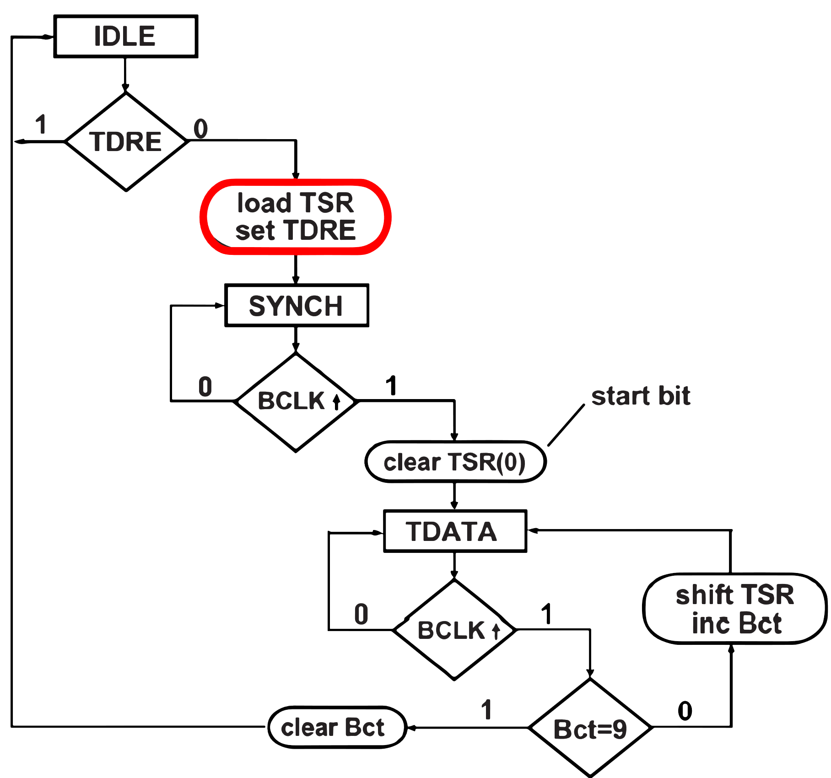

**-Dice Game**

**entity** DiceGame **is**

**port** (Rb, Reset, CLK: **in** **bit**;

Sum: **in** **integer** **range** 2 to 12 ;

Roll, Win, Lose: **out** **bit**) ;

**end** DiceGame ;

**architecture** DiceBehave **of** DiceGame is

**signal** State, Nextstate: integer range 0 to 5;

**signal** Point: integer range 2 to 12;

**signal** Sp: bit;

**begin**

**process** (Rb, Reset， Sum, State)

**begin**

Sp<='0';Roll<='0';Win<='O';Lose<='0';

**case** State **is**

**when** 0 =>

**if** Rb='1' **then** Nextstate<=1;

**end** **if**;

**when** 1 =>

**if** Rb='1' **then** Roll<='1';

**elsif** Sum = 7 **or** Sum = 11 **then** Nextstate <= 2;

**elsif** Sum = 2 **or** Sum = 3 or Sum =12 **then** Nextstate <= 3;

**else** Sp <= '1'; Nextstate <= 4;

**end** **if**;

**when** 2 =>Win<='1';

**if** Reset = '1' **then** Nextstate <= 0; **end** **if**;

**when** 3 =>Lose<='1';

**if** Reset = '1' **then** Nextstate <= 0; **end** **if**;

**when** 4 => **if** Rb = '1' **then** Nextstate <= 5; end **if**;

**when** 5 =>

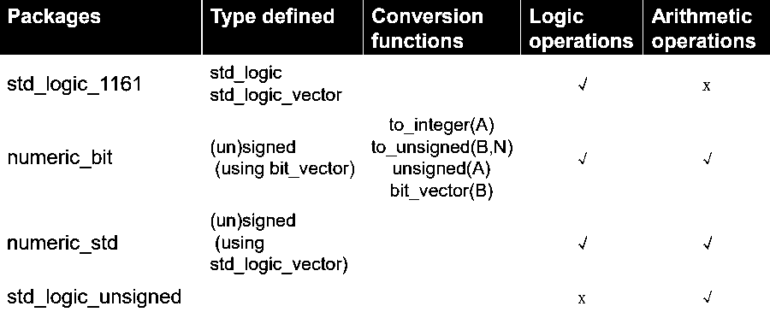**if** Rb='1' **then** Roll <= '1';

**elsif** Sum = Point then Nextstate <= 2;

**elsif** Sum = 7 then Nextstate <= 3;

**else** Nextstate <= 4;

**end** **if**;

**end** **case** ;

**end** **process**;

**process** (CLK)

**begin**

**if** rising_ edge (CLK) **then**

State <= Nextstate;

**if** Sp = '1' **then** Point <= Sum;

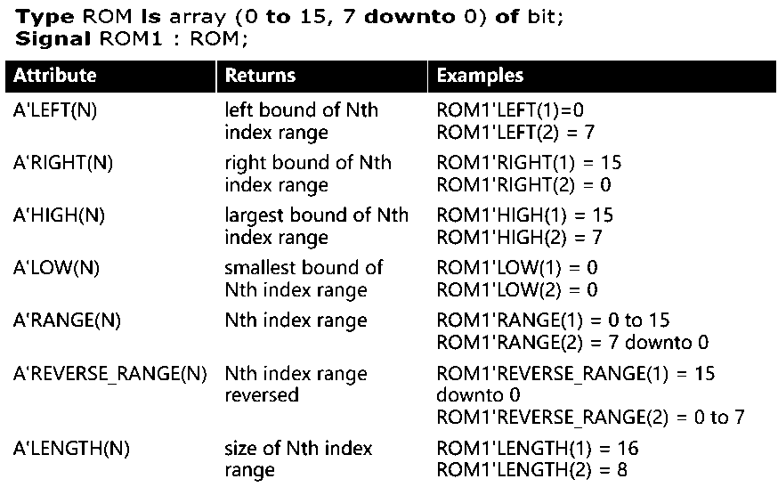**end** **if**;

**end** **if**;

**end** **process**;

**end** DiceBehave;

**-Divider**

**library** **IEEE**;

**use** **IEEE**. numeric_bit.**all** ;

**entity** sdiv **is**

**port**(CLK, St: **in** **bit**; Dbus: **in** **unsigned**(15 **downto** 0) ;

Quotient: **out** **unsigned**(15 **downto** 0);

V，Rdy: **out** **bit**) ;

**end** sdiv;

**architecture** Signdiv **of** sdiv **is**

**signal** State: **integer** **range** 0 to 6;

**signal** Count: **unsigned**(3 **downto** 0);

**signal** Sign，C，Cm2: **bit**;

**signal** Divisor, Sum，Compout: **unsigned**(15 **downto** 0);

**signal** Dividend: **unsigned**(31 **downto** 0) ;

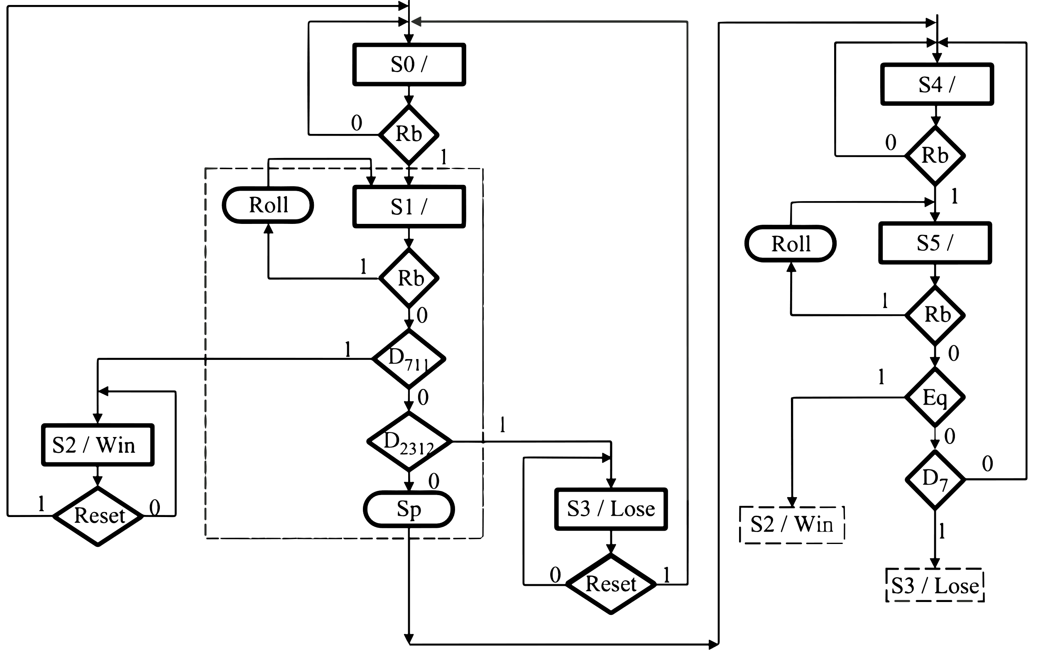**alias** Acc: **unsigned**(15 **downto** 0) **is** Dividend(31 **downto** 16);

**begin**

Cm2 <= **not** divisor(15);

compout <= divisor **when** Cm2 = '0' **else** **not** divisor ;

Sum <= Acc + compout + **uns** **igned'** (0=>Cm2) ;

C <= **not** Sum(15) ;

Quotient <= Dividend(15 **downto** 0)

Rdy <='1' **when** State = 0 **else** ‘0’;

**process** (CLK)

**begin**

**if** CLK' event **and** CLK =' 1' **then**

**case** State **is**

**when** 0 =>

**if** St = '1' **then**

Acc <= Dbus ; -- load upper dividend

Sign <= Dbus (15);

State <= 1 ;

V <= '0'; -- initialize overf1ow

Count <=0000"; -- initialize counter

**end** **if**;

**when1**=>Dividend(15 **downto** 0) <=Dbus; -- load lower dividend

State <= 2;

**when** 2 =>

Divisor <= Dbus;

**if** Sign = '1' **then** -- two's complement Dividend if necessary

Dividend <= **not** Dividend + 1;

end if;

State <= 3;

**when** 3 =>

Dividend <= Dividend(30 **downto** 0) & '0'; -- left shift

Count <= Count + 1;

State <= 4;

**when**_ 4 => if C = '1' **then**

V <=’1’;

State <= 0;

**else**

Dividend <= Dividend(30 **downto** 0) & '0';

Count <= Count + 1;

State <= 5;

**end** **if**;

**when** 5 => **if** c ='1' then

Acc <= Sum; --subtract

Dividend(0) <=‘ 1 ' ;

**else**

Dividend <= Dividend(30 **downto** 0) & '0'; -- left shift

**if** Count = 15 **then** State <= 6; **end** **if**; -- KC'

Count <= Count + 1 ;

**end** **if**;

**when** 6 => State <= 0;

**if** C = '1'' **then**

Acc <= Sum; --subtract

Dividend(0) <='1’;

State <= 6 ;

**elsif** (Sign xor Divisor(15)) ='1' **then**

Dividend <= **not** Dividend + 1;

**end if;**

**end case;**

**end** **if**;

**end** **process** ;

**end** Signdiv;

In the following VHDL process A, B, C, and D are all integers that have a value of 0 at time = 10 ns. If E changes from '0' to '1' at time = 20 ns, specify the time(s) at which each signal will change and the value to which it will change. List these changes in chronological order (20, 20+Δ, 20+2Δ, etc. )

